**KWAME NKRUMAH UNIVERSITY OF SCIENCE AND TECHNOLOGY, KUMASI**



DEPARTMENT OF COMPUTER ENGINEERING

COE 287: CIRCUIT THEORY

PROJECT No 29

OTENG TANO KOJO

3038220

**Transient Analysis of The Above RL Circuit Using LT Spice**

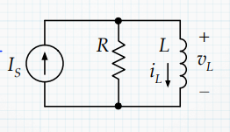

In the above circuit, at time (*t* )=0, **Is** would change instantaneously from the initial current **Ii** to **If**

The current through resistor R at t=0 is iR which is also 0.

In relation, the voltage through the inductor L (v­L) at t=0 is given as

VL (0) =R [ If – iL (0) ] = R [ If – Ii ]

But when t>0, iL increases while iR and vL decreases.

**Time Constant in RL circuits**

Time constant ($τ$) in an RL circuit is characterized by $$τ=\frac{L}{R}$$

A circuit of inductance of 60Ωs and a resistor of 1000Ω can simulate 6ms of time constant, which means it takes 6ms to fully charge the inductor in such circuit

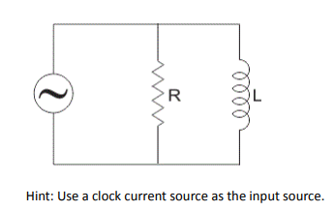

$τ=\frac{L}{R}$ $τ=\frac{60Ωs}{1000Ω}$

$τ=0.06s$

$τ≈6ms$

**LT Spice Simulation of the above circuit**

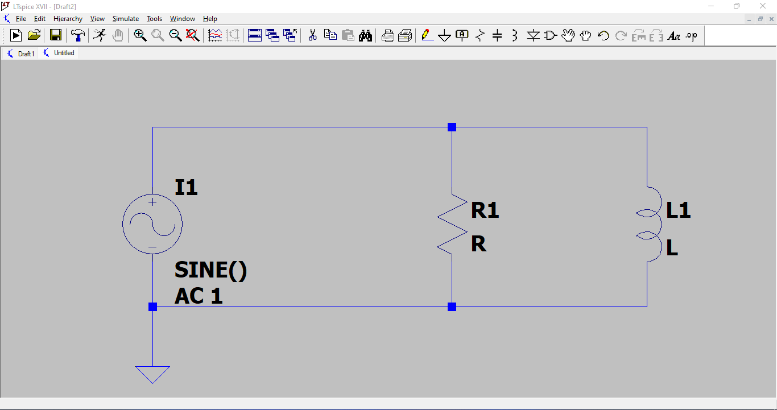

The values of the inductor and resistor are inserted into the software.

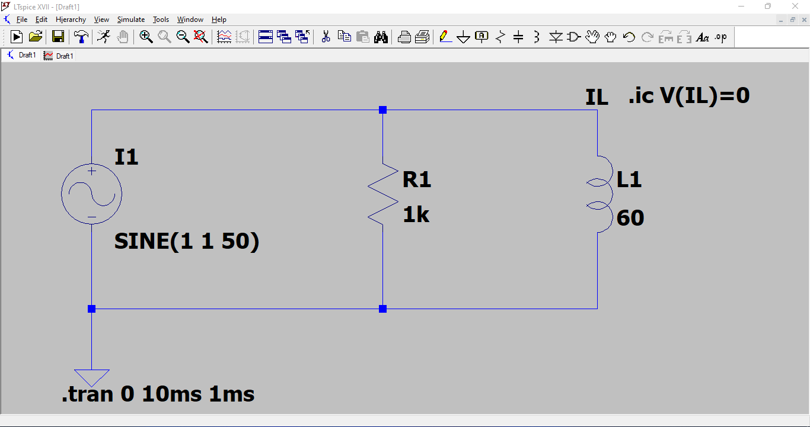

The set-up was simulated to run for 10ms and the results are as follows;

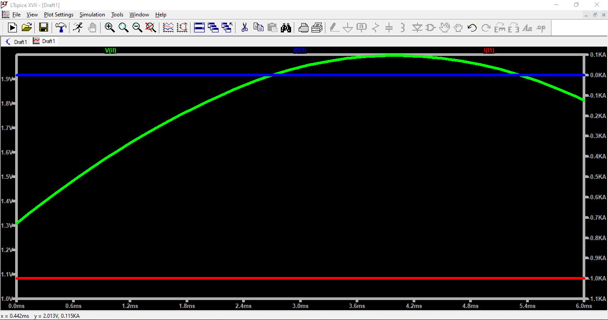

From the graph, the voltage through the inductor (the green curve) shows the charging of the inductor. It rises from 1.3V at t=0 to 1.8V at t=6ms